Read Write Inc. Word time 1.5
red | run
rat | jog
jet | jam
vet | yap
yes | yum
web | win
wish  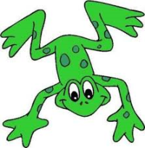 | sock

